Green Cloud Computing

Sarah Martin  
SETU Carlow *Ireland*  
C00257967@Setu.ie

*Abstract*—This paper explores the area of green cloud computing, emphasizing its significance in reducing energy consumption and environmental impact. It highlights the advantages of transitioning from traditional IT infrastructure to cloud-based solutions, such as decreased reliance on physical servers and optimized resource utilization. The paper covers the benefits of green cloud computing, including energy savings, reduced e-waste, and enhanced compliance management. Furthermore, the paper addresses the challenges faced in adopting green cloud solutions and proposes strategies to overcome them, such as implementing multi-cloud or hybrid approaches and establishing a Cloud Center of Excellence. Finally, it delves into future trends, including the integration of AI, quantum computing, edge computing, renewable energy, advanced cooling technologies, and sustainable data center designs. These advancements promise to further minimize the environmental footprint of cloud services, ensuring a sustainable technological future.

Keywords— Green cloud computing, energy efficiency, environmental sustainability, multi-cloud, hybrid cloud, AI, quantum computing, edge computing, renewable energy, data center cooling, sustainable design.

# Introduction

Green cloud computing refers to a sustainable way of cloud computing that involves reducing energy demand and mitigating environmental impact. In recent times, there is a growing trend of “going green” across various aspects of our lives, such as recycling, using energy-efficient devices, driving eco-friendly vehicles, and creating clean energy sources. This trend has propelled the concept of green cloud computing into the spotlight [1].

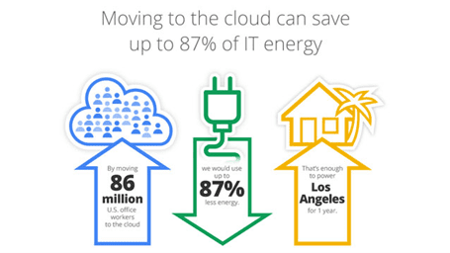

*Fig 1: Moving to the cloud [22]*

**Benefits of Moving IT Infrastructure to the Cloud:**

Transitioning from traditional IT infrastructure to cloud-based solutions offers numerous advantages, including:

**Reduction in Physical Servers**: By migrating to the cloud, organizations can decrease their reliance on physical servers, leading to space savings and reduced energy consumption.

**Increased Utilization of Computing Resources:** Cloud computing allows for better utilization of available computing units, optimizing resource allocation and minimizing waste [2].

Despite its benefits, traditional cloud computing poses significant environmental challenges. Data centres, in particular, consume vast amounts of energy and contribute substantially to carbon emissions. According to a report by the International Energy Agency (IEA), global data centre electricity consumption reached approximately 200 terawatt hours (TWh) in 2020. If current trends persist, this figure is projected to rise to 300 TWh by 2025, exacerbating environmental concerns [3].

In response to the environmental implications of traditional cloud computing, the concept of "green cloud" has emerged. More companies are now evaluating the CO2 emissions and overall environmental impact of their cloud service providers' facilities, reflecting a growing emphasis on sustainability in the technology sector..

# Reasons For Organisations To Transitioning to Green Cloud Computing

In this section, I will examine some of the advantages for companies and organizations adopting green cloud computing. [4]

Increased Energy Savings

* Green cloud computing significantly reduces energy use. This is due to organizations needing fewer physical servers. This means that organizations can have lower utility bills and consume less energy [4]

## Remote Work And Reduced Carbon Footprint

* The rise of cloud computing has made remote working more accessible. Cloud computing has improved the efficiency of remote work, reducing the need for daily commutes. This decrease in commuting helps lower carbon emissions associated with transportation, reducing the overall carbon footprint. [5]

## Reduced E-Waste

* Hardware that is no longer used becomes electronic waste (e-waste). Transitioning to the cloud reduces reliance on physical hardware, leading to less hardware needing disposal. This significantly minimizes the environmental impact of electronic waste.

## Environmental-Friendly Cloud Architecture

* Green cloud computing utilizes energy-efficient hardware and optimizes resource allocation to minimize environmental impact and promote long-term sustainability.

## Compliance Management

* Cloud providers comply with a variety of international and regional standards, which helps businesses meet their regulatory obligations. This adherence to compliance standards is a crucial aspect of governance within the Environmental, Social, and Governance (ESG) framework. [5]

## Green Innovations Made Possible

* Cloud computing provides an ideal environment for fostering green innovations. Companies can utilize cloud platforms to create and implement applications that enhance sustainability, such as smart grid solutions for energy management or applications that encourage responsible consumption. [5]

## Disaster Recovery And Business Continuity

* Green cloud computing offers disaster recovery and business continuity solutions. Cloud providers often have multiple data centers in different geographical locations. This ensures that data is safe and secure even in the event of a local disaster.

Fig 2. Why transition to the Cloud? [23]

# TECHNOLOGICAL STRATEGIES OF GREEN CLOUD COMPUTING

Green cloud computing relies on various types of technology and strategies aimed at reducing energy consumption, optimizing resource utilization, and minimizing environmental impact. In this section, I will examine the components that form the strategies of green cloud computing.

## Placing Data Centers in Suitable locations

Data centers require significant energy to maintain operations, primarily for powering servers and cooling equipment. Locating data centers in cooler climate regions, such as Scandinavia, or underground facilities, reduces the cooling energy required compared to hot climates like deserts or subtropical areas such as the Southern US.

## Optimising Renewable Resources and Energy Efficiency

The main concept behind cloud services is sharing resources over a network and optimizing resource efficiency. Cloud facilities can relocate resources to serve different regions and applications, improving efficiency compared to on-premises data centers.

For example, a cloud facility serving Sydney users during Sydney business hours with specific servers can relocate the same resources to serve European users during European business hours with a different application. This efficiency positively impacts the environment. As data-intensive technologies like AI and distributed manufacturing systems expand, energy efficiency in cloud computing becomes crucial. Modern data centers use advanced technologies like machine learning to maximize cooling efficiency.

They also deploy smart controls for temperature, lighting, and cooling to minimize energy use. Companies like Firstserv Ltd employ renewable energy sources and introduce liquid cooling for processors to reduce their carbon footprint. Ensuring infrastructure suitability for hosting application environments is also essential for mitigating environmental impact.

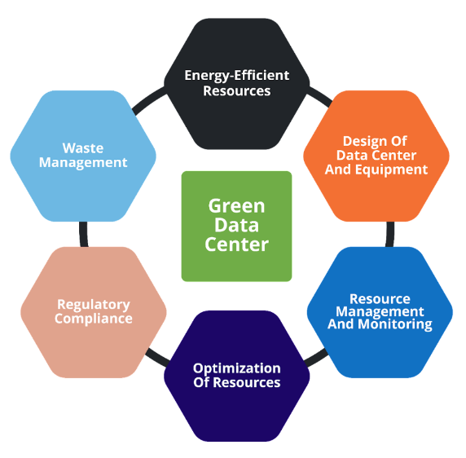

Fig 3. Concepts and Techniques for the Green Data Center [24]

## Steps To Transition to Green Cloud Computing

Transitioning to green cloud computing is a process that can involve careful planning and execution. Below are some key steps to making the transition. [4]

1. IT Setup Assessment

Conduct a detailed assessment of your current IT setup and examine its energy use, carbon footprint, and areas to improve.

1. Set Goals

Create measurable objects for your transition to green computing. This includes targets for reducing energy consumption, making sure carbon footprint is minimized, and calculating the percentage of renewable energy used.

1. Choosing A Good Cloud Service Provider (CSP)

Choose a CSP that makes sustainability a priority and utilizes renewable energy for its data centers. This involves picking providers that prioritize being eco-friendly. Examine any certifications and green projects they are involved in.

1. Implement Server Virtualization

Implement server virtualization to maximize the utilization of physical servers. This reduces the number of physical servers needed. By doing this, it lowers energy consumption and space requirements as it allows multiple virtual servers to run on one physical server.

1. Improve Resource Usage

Optimize resource usage by utilizing cloud computing scalability. Cloud services have the option to be scaled up or down. This means that resources are not over-provisioned and reduces unnecessary energy consumption.

1. Data Center Usage

If you are running your own data center, invest in energy-efficient infrastructure such as cooling systems, energy-efficient servers, and sustainable lighting. All these components combined can significantly reduce energy consumption.

1. Engage with Stakeholders

Educate stakeholders and your team about how important cloud computing sustainability is. Encourage them to consider the above steps so that they can contribute to new ideas and work on contributing to a greener environment.

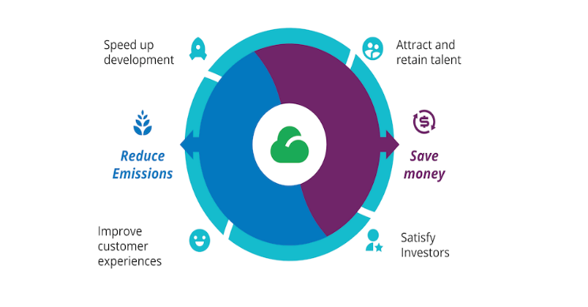

Fig 4. Why green cloud optimization is profitable for you and the planet [25]

# Challenges and Barriers to Adopting Green Cloud Computing

## Transition Costs

Initially transition to green cloud computing it can often involve a significant amount of money to invest in new technologies such as purchasing energy-efficient hardware and renewable energy sources. [6]

## Complexity Of Technology

Implementing green cloud computing often requires technological expertise. Organizations need to make the transfer from the existing IT structure and add in new software tools and train staff. This is an added complexity that could hinder an organization from wanting to adopt green cloud computing solutions. A survey of 64% of respondents reported that finding skilled workers was their biggest challenge. This indicates that many organizations are slowing down when it comes to building new cloud services [7]

## Vendor Lock-In

Being dependent on a single cloud service provider (CSP) can lead to vendor lock-in. This is where an organization may find it difficult and costly to switch providers. This might limit the flexibility of some organizations. [7]

## Resistance To change

Making the switch to green cloud computing can come with changes with an organization. Stakeholders and employees might find the change challenging when it comes to working with new systems. [7]

## Technology Limitations

Some organizations may be dealing with legacy systems which can make it difficult when switching to cloud technology that will be compatible with an organization's current systems. Integrating a legacy system with a new green cloud infrastructure can lead to technical challenges and be costly.

## Concerns Of Performance

There is an awareness that green cloud solutions might not meet the performance standards of traditional IT infrastructure. Organizations might think that putting an energy-efficient system in place might affect speed, reliability, and overall performance.

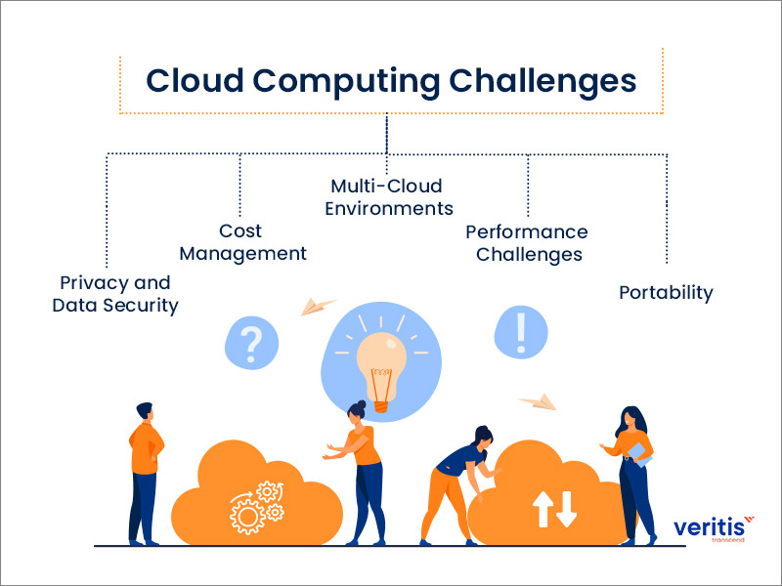

Fig 5. Cloud computing challenges [26]

# Ways To overcome the challenge of adopting green cloud computing

In the previous section, I examined the multiple challenges an organization can face when it comes to adopting green cloud solutions. In this section, I will outline ways that an organization can overcome these challenges. [8]

## Implementing a Multi-Cloud or Hybrid Approach

One way to prevent getting locked in with the same cloud vendor is to allow organizations to choose a multi-cloud or hybrid approach.

* Multi-Cloud Approach: using multiple cloud instances or vendors can prevent vendor-lock-in and enhance competitive pricing. For example, organizations can benefit from competitive pricing by choosing the most cost-effective services from multiple providers.
* Hybrid Approach: This approach involves combining on-premises and cloud solutions for organizations. This measure allows organizations to maintain control over sensitive data while also benefiting from the flexibility and scalability of cloud services. This approach can help with incremental transition to the cloud

## Phase Approach

Moving an entire organization to the cloud can be overwhelming. To begin this process, it's best to start with small increments. [7]

For example, start with moving just one of your systems to the cloud at first. This system could the customer relationship management (CRM).

By doing this step and the results are satisfactory, more solutions and data can be transferred to the cloud. There are a few cloud models to choose from.

1. Public cloud model: this offers on-demand computing and infrastructure that is shared across many different organizations via the public internet.
2. Private Cloud model: this offers a more dedicated environment for a single organization. It offers security and more control.
3. Hybrid cloud model: this combines both on-premises systems and cloud services. This allows for flexibility and scalability by using multiple platforms.

The benefit of transition in phases means you can always change your approach to meet the needs of your organization. You may decide at first to use a public cloud model but then move to a private cloud at a later stage.

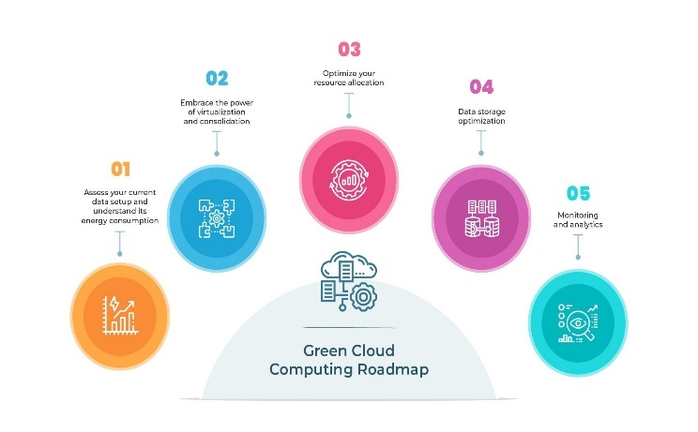

Fig 6. Green cloud computing roadmap [27]

## Create A Cloud Center Of Excellence

Creating A cloud center of excellence within your organization can help with expanding employees’ cloud skills. The Cloud Center of Excellence team is solely responsible for researching options, implementing best practices, and managing ongoing cloud operations.

Creating this team can help your organization identify employees who already have prior knowledge about cloud computing so they can become part of the team. Depending on the current knowledge of employees, the decision can be made to look externally at hiring workers skilled in cloud computing. [7]

With the center in place, members can train additional employees, hire employees, or use a mixture of both.

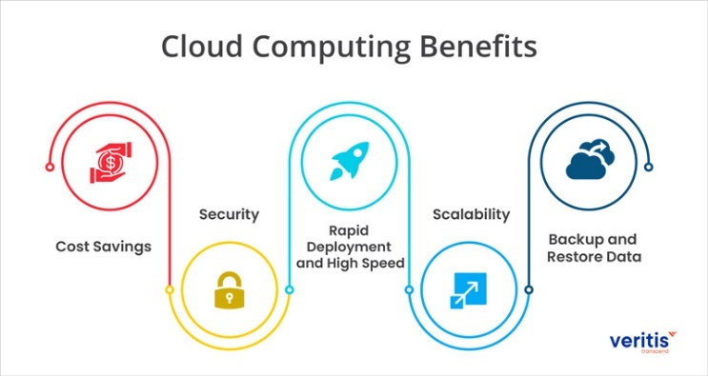

Fig 7. Cloud computing benefits [28]

# Case Studies of Green Cloud Computing Adoption

In this section, I will highlight real-world examples of organizations that have successfully transitioned to green cloud computing. I will highlight their strategies and outcomes.

## Amazon Web Services (AWS)

In recent years, AWS has made significant changes when it comes to green cloud computing by improving their energy efficiency in their data centers and investing in renewable energy projects.

AWS aims to power its operations with 100% renewable energy by 2025. AWS has been working towards this goal by using various strategies. These strategies include investments in wind and solar farms around the world which in return generate renewable energy to offset their data center consumption [12]

AWS has also implemented technology to improve the energy efficiency of its facilities such as its data centers.

They have implemented cooling systems and custom hardware that are optimized for lower power consumption.

AWS is also committed to reducing water consumption within its data centers and support policies to advance renewable energy.

AWS has already reached 65% renewable energy usage and continues to expand its renewable energy projects to meet its 2025 goal.

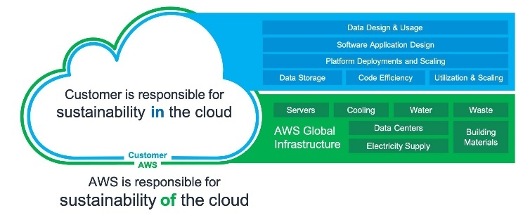

Fig 8. AWS cloud sustainability [29]

## Microsoft Azure

Microsoft Azure has implemented different investment measures when it comes to sustainability. Some of these measures include using renewable energy and cooling technologies.

Microsoft has a goal to be carbon-negative by 2030. Their approach to achieving this goal is to transition to 100% renewable energy for their data centers by 2025 and eliminate their reliance on diesel fuel by 2030. [10]

Microsoft also plans to develop energy-efficient data centers that leverage advanced cooling systems such as using immersion cooling which greatly reduces energy consumption. [11]

Microsoft is also focusing on reducing Scope 3 emissions. This includes all emissions that occur in the company’s value chain. [10]

Microsoft's new technologies look at exploring the ability to reduce their carbon footprint to achieve their 2030 goal.

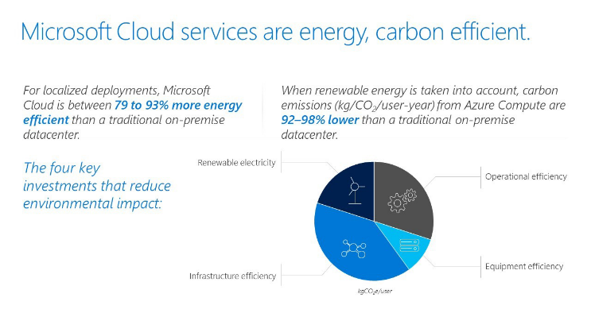

Fig. 9. Microsoft Cloud services are energy, carbon-efficient [30]

## Google Cloud

Google Cloud has achieved carbon footprint neutrality since 2007. Google Cloud also aims to operate solely on carbon-free energy by 2030. Google Cloud has outlined some of their ways of reducing environmental impact. [8] This includes:

* Purchasing renewable energy to match their global energy use in areas of artificial intelligence.
* They have dedicated projects aimed at developing new renewable energy projects such as wind and solar farms.

They also talk about their efforts in creating sustainable data centers that use 50% less energy than most facilities, looking at the use of machine learning to improve energy efficiency and they have a program for reducing water consumption.

With these initiatives in place, Google Cloud can provide carbon neutrality but also keep its goal of operating on carbon-free energy. [9]

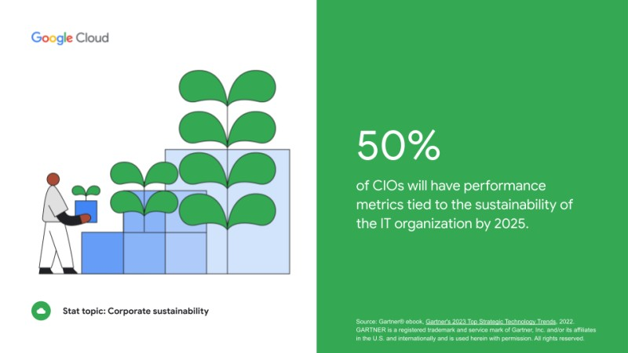

Fig 10. CIOs performance metrics [31]

# Future trends in green cloud computing

Green cloud computing is growing rapidly due to advancements in technology and increasing environmental awareness. In this section, I will examine some of the growing trends in this field

## Artificial Intelligence & Machine Learning

Artificial Intelligence and Machine Learning are currently being integrated into data centers to help optimize energy use

These technologies examine patterns and predict workloads. This allows for adjustments needed for cooling systems and power distribution, helping with reducing energy consumption.

For example, Google’s DeepMind AI is used to reduce the energy for cooling data centers by up to 40% [13]

## Quanting Computing

Quantum computing can potentially help cloud computing revolutionize energy efficiency. Quantum computing carries out complex calculations that cannot be performed by classical computers and significantly reduces the computational energy needed.

Using quantum computing could lead to increased energy savings, particularly for tasks such as optimization problems and large-scale simulations.

Companies like IBM are exploring how to integrate quantum computing into their cloud services while maintaining sustainability [14]

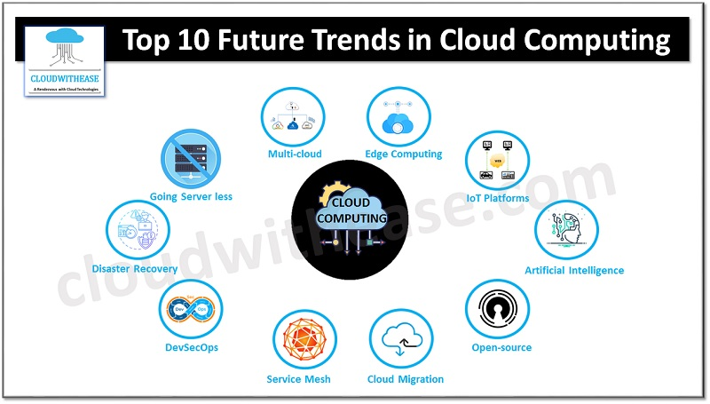

Fig 11. Top 10 future trends in cloud computing [32]

## Edge Computing

Edge Computing helps with bringing processing power closer to data generation which helps with reducing energy consumption as it reduces the need for data to travel long distances to data centers.

This decreases latency but also reduces energy consumption as it limits the amount of data being transmitted across networks. [15]

Edge computing also leverages local resources for processing which lowers the overall energy footprint of cloud services.

For example, Amazon Web Services (AWS) is creating edge computing solutions that integrate with their cloud platforms. [16]

## Increased Use of Renewable Energy

Recently there has been a trend of power dating centers using energy sources such as wind and solar power. Companies are now investing in renewable energy projects to ensure that their cloud operations are sustainable. As discussed in the previous section, Microsoft has planned to be carbon-negative by 2030 as it plans to power its data centers entirely with renewable energy.

Innovations in energy storage are enabling more reliable and efficient use of renewable energy in cloud computing. These energy storages include battery technologies and grid storage. [17]

E. Advanced Cooling Technologies

Liquid cooling systems are becoming more popular due to their higher efficiency in heat removal. Companies like Google are looking at liquid cooling solutions to reduce the energy required for cooling their data centers as its seen as a more sustainable alternative to air cooling. [18]

Immersion Cooling:

In immersion cooling, servers are placed in thermally conductive liquids, which can reduce cooling energy requirements. This technology is being adopted by companies looking to maximize energy efficiency and reduce their environmental impact [19].

F. Sustainable Data Center Design

Modular data centers are designed to be scalable and allow for rapid development. These centers can be designed with energy efficiency in mind, using sustainable building materials and advanced cooling systems [20].

Green Building Certifications:

Data centers are increasingly seeking certifications like LEED (Leadership in Energy and Environmental Design) to demonstrate their commitment to sustainability. These certifications ensure that data centers meet strict environmental standards, covering everything from energy use to water efficiency. [21]

# CONCLUSION

The transition to green cloud computing represents a critical step towards a more sustainable and environmentally friendly technological future. The benefits of moving IT infrastructure to the cloud, such as reducing physical servers, optimizing resource utilization, and decreasing carbon emissions, are substantial. Companies that adopt green cloud computing practices not only contribute to environmental sustainability but also realize significant operational efficiencies and cost savings.

##### References

[1] Salama, M. (2020). *Green Computing, a contribution to save the environment*. [online] www.lancaster.ac.uk. Available at: https://www.lancaster.ac.uk/data-science-of-the-natural-environment/blogs/green-computing-a-contribution-to-save-the-environment#:~:text=In%20basic%20terms%2C%20Green%20Computing.

‌

[2] Emily (2024). *The ‘Green Cloud’: Four strategies for a sustainable and responsible digital future*. [online] Open Access Government. Available at: https://www.openaccessgovernment.org/green-cloud-four-strategies-sustainable-and-responsible-digital-future/166931/#:~:text= [Accessed 20 May 2024].

‌

[3] IEA (2023). *Data centres & networks*. [online] IEA. Available at: https://www.iea.org/energy-system/buildings/data-centres-and-data-transmission-networks.

‌

[4] Integrio Systems. (n.d.). *What is green cloud computing and how it benefits organizations*. [online] Available at: https://integrio.net/blog/what-is-green-cloud-computing#:~:text=Organizations%20that%20use%20green%20cloud

‌

[5] Kent (2023). *Benefits of Cloud Computing for ESG and Sustainable Business Practices*. [online] Document Management System Folderit. Available at: <https://www.folderit.com/blog/benefits-of-cloud-computing-for-esg-and-sustainable-business-practices/>.

‌[6] Ahmad, A., Khan, S.U., Khan, R.A., Alwageed, H.S. and Al-Atawi, A.A. (2023). Green Cloud Computing Adoption Challenges and Practices: A Client’s Perspective based Empirical Investigations. [online] doi:https://doi.org/10.21203/rs.3.rs-2793337/v1.

‌[7] Parallels Remote Application Server Blog - Application virtualization, mobility and VDI. (2021). *Top 3 Cloud Adoption Challenges and How to Overcome Them*. [online] Available at: https://www.parallels.com/blogs/ras/overcome-cloud-adoption-challenges/.

‌

[8] Google Cloud. (n.d.). *Carbon free energy for Google Cloud regions*. [online] Available at: https://cloud.google.com/sustainability/region-carbon#:~:text=We%20recently%20set%20a%20goal [Accessed 20 May 2024].

‌

[9] Google (2022). *Carbon-Free Energy | Google Sustainability*. [online] Google Sustainability. Available at: <https://sustainability.google/progress/energy/>.

[10] Smith, B. (2020). *Microsoft Will Be Carbon Negative by 2030*. [online] The Official Microsoft Blog. Available at: https://blogs.microsoft.com/blog/2020/01/16/microsoft-will-be-carbon-negative-by-2030/.

‌

[11] Source. (n.d.). *To cool datacenter servers, Microsoft turns to boiling liquid*. [online] Available at: https://news.microsoft.com/source/features/innovation/datacenter-liquid-cooling/.

‌

[12] Amazon (2024). *Carbon-Free Energy*. [online] Sustainability (US). Available at: https://sustainability.aboutamazon.com/climate-solutions/carbon-free-energy?energyType=true.

‌

[13] Evans, R. and Gao, J. (2016). *DeepMind AI reduces google data centre cooling bill by 40%*. [online] Google DeepMind. Available at: https://deepmind.google/discover/blog/deepmind-ai-reduces-google-data-centre-cooling-bill-by-40/.

‌

[14] IBM (2024). *What is quantum computing?* [online] IBM. Available at: https://www.ibm.com/topics/quantum-computing.

‌

[15] Singh, A. (2022). *What is Edge Computing, and Why is it Critical? - Shiksha Online*. [online] Shiksha.com. Available at: https://www.shiksha.com/online-courses/articles/what-is-edge-computing/#:~:text=In%20a%20simple%20way%3A%20edge

‌

[16] Amazon Web Services, Inc. (n.d.). *AWS for the Edge - Services | Amazon Web Services*. [online] Available at: https://aws.amazon.com/edge/services/.

‌

[17] <https://spectrum.ieee.org/energy-storage-renewables-cloud-computing>

[18] https://datacentremagazine.com/data-centres/googles-watershed-responsible-data-centre-water-use

[19] https://www.greentech.technology/media#:~:text=Our%20modular%20Immersion%20Cooled%20Data,greener%20future%20for%20us%20all.&text=We%20are%20proud%20to%20join,with%20a%20positive%20environmental%20impact!

[20] www.datacenterfrontier.com. (n.d.). *StackPath*. [online] Available at: https://www.datacenterfrontier.com/sponsored/article/11436940/why-modular-data-centers-are-good-for-the-environment.

‌

[21] https://support.usgbc.org/hc/en-us/articles/12154267763987-Applying-LEED-to-data-center-projects#:~:text=LEED%20is%20the%20world's%20first,successfully%20demonstrate%20their%20sustainability%20goals

[22] Lbl.gov. (2013). *Cloud Computing Saves L.A.-sized Power Bill, Study Finds*. [online] Available at: https://cs.lbl.gov/news-media/news/2013/cloud-computing-energy-savings/.

‌

[23] www.linkedin.com. (n.d.). *Embarking on your Data Adventure: Transitioning to Cloud*. [online] Available at: https://www.linkedin.com/pulse/embarking-your-data-adventure-transitioning-cloud-devendra-goyal/

‌[24] Device42. (n.d.). *Concepts and Techniques for the Green Data Center*. [online] Available at: https://www.device42.com/data-center-infrastructure-management-guide/green-data-center/.

‌

[25] www.thoughtworks.com. (n.d.). *Green cloud tools are profitable for you and the planet*. [online] Available at: https://www.thoughtworks.com/insights/articles/green-cloud.

‌

[26] Anon, (n.d.). *Cloud Computing Trends, Challenges & Benefits*. [online] Available at: https://www.veritis.com/blog/cloud-computing-trends-challenges-and-benefits/.

‌

[27] www.datadynamicsinc.com. (2023). *Green Cloud Computing: 5 Impactful Strategies Leading to Net Zero*. [online] Available at: https://www.datadynamicsinc.com/quick-bytes-accelerating-the-net-zero-dream-5-ways-green-cloud-computing-empowers-enterprises/.

‌

[28] Anon, (n.d.). *Cloud Computing Trends, Challenges & Benefits*. [online] Available at: https://www.veritis.com/blog/cloud-computing-trends-challenges-and-benefits/.

‌

[29] aws.amazon.com. (2021). *Optimizing your AWS Infrastructure for Sustainability, Part I: Compute | AWS Architecture Blog*. [online] Available at: <https://aws.amazon.com/blogs/architecture/optimizing-your-aws-infrastructure-for-sustainability-part-i-compute/>.

‌[30] www.datadynamicsinc.com. (2023). *Green Cloud Computing: 5 Impactful Strategies Leading to Net Zero*. [online] Available at: <https://www.datadynamicsinc.com/quick-bytes-accelerating-the-net-zero-dream-5-ways-green-cloud-computing-empowers-enterprises/>.

‌[31] www.linkedin.com. (n.d.). *Google Cloud on LinkedIn: 40 cloud computing stats and trends to know in 2023 | Google Cloud Blog*. [online] Available at: https://www.linkedin.com/posts/google-cloud_40-cloud-computing-stats-and-trends-to-know-activity-7037465335154798592-ADQ5/?originalSubdomain=ie [Accessed 20 May 2024].

## 